Guide to Creating a
Multi-Agency Joint Organisational Learning
Memorandum of Understanding
Between Responder Agencies

Multi – Agency Joint Organisational Learning (JOL) MOU between Responder Agencies

Background
It is imperative that learning from incidents, exercises and training are shared with partners across the responder community. The key message to responder agencies is that Joint Organisational Learning is not about “who” but about “what” and “why”.

These responsibilities are further reflected in legislation and sector standards and are set out in the following:
- Health, Safety and Welfare etc. Act 1974
- Management of Health and Safety Regulations 1999
- Civil Contingencies Act 2004
- Human Rights articles including Articles 2, 6 & 8

Purpose
The purpose of the memorandum of understanding is to ensure there is an agreement and structured process for identifying multi-agency lessons and notable practice between responder agencies. The multi-agency identified areas will then be uploaded to Joint Organisational Learning (JOL) Online using an agreed process.

The Civil Contingencies Act 2004 places requirements, through statutory and non-statutory guidance that Local Resilience Forums and Category 1 responders must collectively:
- Learn and implement lessons from exercises
- Share lessons learned from emergencies and exercises in other parts of the UK
- Make sure that those lessons are acted on to improve local arrangements

Scope
The MOU outlines the rationale and process for identifying and sharing multi-agency lessons / notable practice with partner agencies.

Identifying Multi Agency Lessons and Notable Practice

Capturing Lessons

- Joint hot debrief (where possible)
- Where multi-agency lessons are identified these should be submitted onto JOL Online and may be submitted on the relevant single service platform.
- Multi-agency debriefs - It cannot be emphasised enough that debriefs are a critical source of capturing lessons identified. Responder agencies must embed within their local debrief processes, the facility to capture lessons relating to interoperability between any organisations, the application of JESIP principles and models and national resilience capabilities. Only by adopting this locally can we ensure lessons are identified, captured, shared and effectively learnt across all UK responder agencies.
Any issues raised as part of de-briefing which meet any or all of the following criteria should be submitted onto JOL Online.

Responders should input their lessons identified into JOL Online when:

Lessons Identified:
- The lesson identified may have an impact on responder agencies interoperability measured against JESIP Principles for joint working;
- The lesson identified may have a national impact;
- The lesson identified may impact on your organisations national standards;
- The lesson identified may impact on effectiveness of your sectors current national operational guidance, approved professional practice or doctrine;
- The lesson identified may impact on effectiveness of current national resilience capabilities;
- You want to share your lessons identified with other responder agencies to promote learning;
- The lesson identified is low impact but high frequency (trend).
- This is not a definitive list and if organisations feel that a lesson should be recorded on JOL, they should do so.

Notable Practice (as defined in the JOL Guidance):
- Activities that you have identified that may positively improve responder’s interoperability, measured against JESIP Principles for joint working;
- Activities that you have identified that may positively improve national resilience capabilities;

On receipt of lessons identified from incidents, exercises and training seek to close any gaps in understanding, awareness, gaps in practical applications of the principles of JESIP through revisions to training course, general information to commanders etc.
Review any national / local JOL action notes at each multi-agency meeting, assess the impact on services and / or receive assurance of action / implementation in responder agencies.

National

- Review national JOL action notes for incorporation locally
- Review national agendas and change
- Manage information flow from the central JESIP team

Process
Each organisation or LRF must have a named individual at strategic level who holds the responsibility for sharing information onto JOL Online and a JOL Single Point of Contact. Each organisations Strategic lead is also accountable and responsible for the local implementation and assurance of all JOL Action Notes which have been approved by the Interoperability Board.

Memorandum of Understanding (MoU)
For responder agencies to ensure continuous and sustainable processes are agreed locally to capture, share and learn lessons from each other across the UK local agreements should be agreed around Joint Organisational Learning.

The JESIP Assurance of services 2017 identified that, although there were elements of good practice locally across a range of forums around agreeing which lessons and notable practice should be shared on JOL Online, there remains a lack of formal agreements to support the good work undertaken to date. Therefore, the Interoperability Board have agreed that to ensure that the embedding of JESIP and JOL is as effective and sustainable as possible, a MoU should be agreed between responder agencies locally to support JOL.

An example of a MoU for responder agencies to adopt is attached in Appendix A.

Appendix A

Memorandum of Understanding

Between
insert Police Force
and
insert Fire & Rescue Service
and
insert Ambulance Service
and
insert Local Resilience Forum
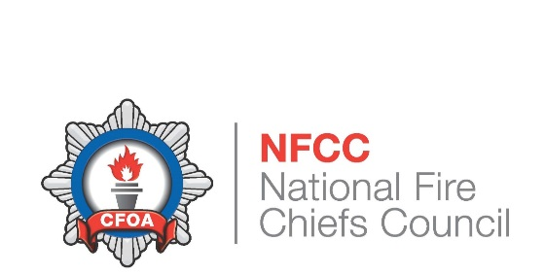
Insert own badges here

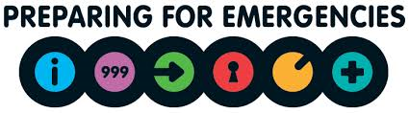

This Memorandum of Understanding (MoU) is between insert Police force, insert Fire & Rescue Service, insert Ambulance trust and insert LRF.

1) This MOU is a statement of intent between insert Police force, insert Fire & Rescue Service, insert Ambulance Service and insert Local Resilience Forum.

2) The intent is that in the interests of working together saving lives and reducing harm and adoption of the aim of Joint Organisational Learning (JOL) - learning together for safer stronger communities, the parties identified in 1) will work closely together to share appropriate local, regional and national single and multi-agency lessons identified and notable practice with partners across the UK. Effective implementation of this MoU will improve emergency planning, response and recovery arrangements and ultimately, public and emergency responder safety.

3) This will be achieved by:

a. Parties in 1) committing to initiate and maintain communication at the outset of any multi-agency event that may require the identification and recording of lessons identified and/or notable practice.

b. Ensuring interoperability is a core element of all multi-agency debriefs

c. Committing to the open exchange and timely sharing of multi-agency lessons with responder agencies across the UK.

d. Identification of a JOL single point of contact(s) with the necessary skills and responsibilities who will record lessons onto JOL Online on behalf of relevant responder agencies.

e. Using JOL Online as the single system for reporting and sharing all multi-agency lessons and notable practice

4) This MoU is not intended to create a legal relationship between the parties and no legal obligations or legal rights shall arise between the parties from this MoU.

5) This MoU does not take away any responsibility, seek to replace, or affect, the normal sharing of information protocols that exist between Police forces, Fire & Rescue Services, Ambulance Trusts and Local Resilience Fora. This MoU is simply a statement of intent to foster genuine and mutually beneficial co-operation, therefore ensuring that responder agencies learn lessons to ensure our communities are provided with the most effective response to emergencies.

Review

- This MoU will be reviewed annually or after any issue agreed by parties 1) that determine a review.

Governance

- The responsibility for the periodic review of this MoU is with the relevant Local Resilience Forum executive board.

Signed: insert Police force Date:

Signed: insert Fire & Rescue Service Date:

Signed: insert Ambulance Service Date:

Signed: insert Local Resilience Forum Date:

Document Control

Active date | Review date | Author | Role | Publisher

Amendment History

Version | Date | Reason for change | Amended by

Joint Organisational Learning Guidance, October 2017

