JESIP Umpire Evaluation Template

December 2021

Version 3



|  |  |
| --- | --- |
| *Date of event:* |  |
| *Location:* |  |
| *Type of exercise:*  *(TTX, live play, hybrid, other)* |  |
| *Umpire Team Names:* |  |
| *Exercise Objectives:* |  |

*Are commanders easily identifiable (tabards or other appropriate markings which identify them as a commander)?*

*What command structures are in place?*

*Have commanders met face to face?*

*Has a Forward Command Post (FCP) been established?*

*Have commanders had timely on-scene briefings?*

*Is common terminology being used?*

*Is an Airwave interoperability talk group being used?*

*Is relevant information being shared across all services and control rooms throughout the incident?*

*Was M/ETHANE used to pass information to control and shared between agencies*

*Were effective communications established between:*

*Operational, tactical and strategic commanders/commanders and control rooms/Emergency service commanders and other responding organisations/Local emergency service control rooms/Emergency service control rooms and national co-ordinating centres?*

*Are commanders using the JDM as single decision model?*

*Have capabilities, limitations & responsibilities been identified?*

*Have joint decisions on priorities been made and if so, how were the priorities arrived at and agreed?*

*Were actions joined up and therefore efficient and effective?*

*Were ALL on scene resources used appropriately?*

*Was there an understanding of the capability, capacity and limitations of each other’s assets?*

*Did someone take the lead co-ordinators role during Multi-Agency meetings and was this a joint decision between all agencies present*

*Was duplication of effort negated?*

*Is the JDM used as a briefing tool?*

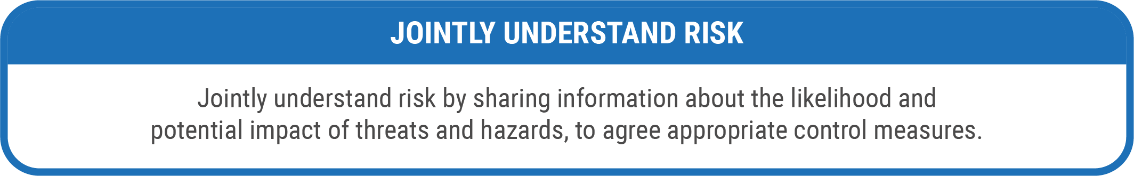

*Are threats and hazards being identified, understood and treated different by each emergency service?*

*Have limitations and capabilities of people and equipment been identified?*

*Has a joint understanding of risk been achieved by sharing information about the likelihood and potential impacts of threats and hazards*

*Have single agency risk assessments been shared?*

*Do Commanders have a common understanding of what has happened, what is happening now and the consequences of events?*

*Do controls know what is happening and are they kept informed?*

*Do each of the emergency services understand their roles in resolving the emergency?*

*Is M/ETHANE regularly being used to provide a Common Operating Picture (COP)*

*Was the Joint Decision Model utilised identifying:*

*Situation - What is happening? the impacts and risks; what might happen and what is being done about it? what is the aim and objective of the emergency response? what priorities will inform and guide direction?*

*Direction - What end state is desired? What is the aim and objective of the emergency response? What priorities will inform and guide direction?*

*Action - Are actions being decided? What is needed to be done to achieve a positive end state?*

Control Room Information

*At the point of mobilisation of resources, did each control room have the same picture?*

*Throughout the incident, was a common operating picture clearly identified?*

*Did informative messages from each service have conflicting information?*

*When Major Incident was declared did commanders utilise the M/ETHANE mnemonic?*

|  |  |
| --- | --- |
| 1 | Notes for debrief |
| 1 |  |
| 2 |  |
| 3 |  |
| 4 |  |
| 5 |  |
| 6 |  |
| 7 |  |
| 8 |  |
| 9 |  |
| 10 |  |

**Have you identified anything that impacted on the joint response of the services involved?**

If yes, please ensure the details of the Lesson Identified or Notable Practice are discussed as part of the exercise debriefing process and then entered onto the JESIP Joint Organisational Learning (JOL) database: JOL Online, either via a JOL User or your organisation/LRF JOL Single Point of Contact.