# METHANE – Shared Situational Awareness for Control Rooms

From December 2013 onwards, operational and tactical commanders in police, fire and ambulance services will be receiving training that uses a single method for the sharing of information between commanders, the incident ground and control rooms.

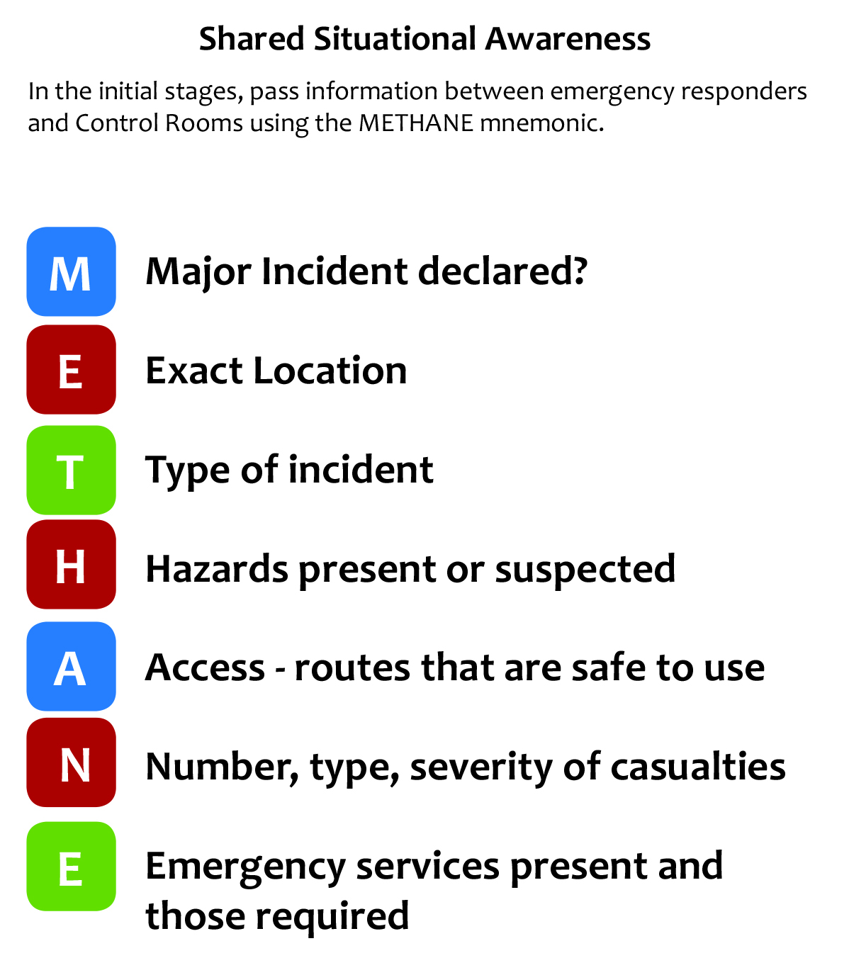Until appropriate training is received, Control Room staff should be aware incident reports from commanders may be received using the mnemonic **METHANE** instead of CHALETS or SAD CHALETS.

This method has been agreed as a clear a simple method to obtain the critical information.

Current control room systems may not be designed to receive information in this order, therefore, in the interim period, control rooms may wish to use the **Incident Initiation Form** on page 2 to help ensure all relevant information is gathered.

The form can then be referred back to at any time to ensure all relevant information is entered onto systems correctly. Once complete the form should be retained with any logs created for the incident.

**Incident Initiation Form**

|  |  |  |  |
| --- | --- | --- | --- |
| Time of Call |  | Date |  |
| Organisation |  | | |
| Name of Caller |  | Tel No |  |

|  |  |  |
| --- | --- | --- |
| Major incident | **Major incident declared Yes / No?**  (Include date & time of declaration and which organisation declared) |  |
| Exact Location | Exact location / geographic area of incident |  |
| Type of Incident | Flooding / Fire / Utility Failure / HazMat/ Disease outbreak etc. |  |
| Hazards | Present or suspected |  |
| Access | Routes that are safe to use, any inaccessible routes and RVP’s |  |
| Number of casualties | Numbers, type and severity |  |
| Emergency Services | Present and those required |  |

*Restricted once*

Signature (once complete) *complete*