A group of people wearing military uniforms

Description generated with very high confidence

**EXECUTIVE SUMMARY**

**Welcome to the latest edition of the Joint Organisational Learning (JOL) Online monthly.**

*This edition covers*

MONTHLY **EDITION 7:** *January 2019*

A group of people wearing military uniforms

Description generated with very high confidence

KEEP INFORMED THROUGH

[**JOL@JESIP.ORG.UK**](mailto:JOL@JESIP.ORG.UK)

**JOL FAQs**

This month, a document containing frequently asked questions regarding JOL and JOL Online was sent to each JOL Mailbox and Single Point of Contact (SPoC).

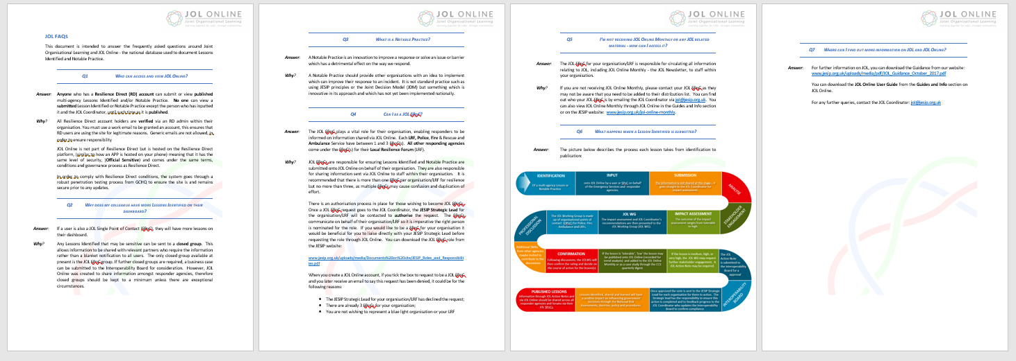

It covers a range of frequently asked questions from ‘what is a ‘Notable Practice’?’ to the JOL Process. If you have any questions regarding JOL please get in touch and your question could be added to the next edition of the FAQs.

You can find the document from the JESIP website: <https://jesip.org.uk/umpire-evaluation-sheets> or find it in the guides and info section of JOL Online.



**New Categories**

We continue to update the JOL Online system following feedback from JOL Online Users. New categories have been added including BREXIT, drones and

# Organisational Development Unit

# blurb.

**Rave Incidents**

We have been asked by a responding agency for any information to assist the response to rave incidents. If you have any lessons identified or notable practices could you please submit to JOL Online so we can share with other responding agencies.



KEEP INFORMED THROUGH

[**JOL@JESIP.ORG.UK**](mailto:JOL@JESIP.ORG.UK)

**Please let us know if you have any comments or recommendations to improve JOL Online. REMEMBER – This is YOUR System!**

# JESIP Umpire Evaluation Template

# The team has recently updated the JESIP Umpire Evaluation Template for use during any multi-agency exercise.

# You can download this document, alongside all of the documents which are there to support you when involved with a multi-agency exercise, from the planning phase to debriefing, on the downloads section of the JESIP website:

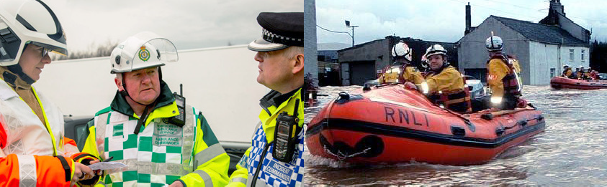

Photograph: brandquarterly.com

**LESSON IDENTIFIED**

**LI01365**

A recent incident resulted in a near miss when working around rail. It is vital you ensure all first responders are safe and communicated with before the railway line is re-opened. We will keep you updated with the progress of this lesson.

**LESSON IDENTIFIED**

**LI01352**

At a recent incident it was identified that carbon monoxide from the exhaust of an outside generator had entered through the cavity of a nearby domestic address. This should be considered when completing risk assessments regarding the placement of portable generators.

If you have any multi-agency photographs from incidents, exercising or training that you would like to share with us – please email them in to [jol@jesip.org.uk](mailto:jol@jesip.org.uk)

We would welcome photographs from ANY responding agency to use in our JESIP publications such as the JOL Online Monthly.

# NOTABLE PRACTICE

**NP01347**

An LRF has created information folders for their SCG commanders. These folders include:

* JESIP material
* a list of powers and policies
* The LRF Emergency Procedures Manual
* SCG and TCG Aide Memoire
* Strategic Policy
* Standardized agreed agendas
* common objectives

These folders provide a better understanding of LRF procedures, documentation and JESIP principles.

The same will be produced for TCG, Cell Chairs & Command Support Managers.

**NOTABLE PRACTICE**

**NP01331, NP01343, NP01344**

A Police Service has kindly shared their documentation with all JOL Online SPoCs to assist other agencies to provide assurance with regards to embedding JESIP. There is also an Organisational Learning document which documents their procedures for learning within their organisation.

**LESSON IDENTIFIED**

**TREND**

A number of submissions have been received regarding initial information not being shared amongst responding agencies. The use of METHANE when communicating between control rooms encourages a robust process to ensure all relevant information is shared.

Users 1483

Organisations 991

Drones has now been added to JOL Online.

If you have any lessons identified or notable practices regarding drones, you can select this in the risk category field.

**CCS Survey**



# JOL ONLINE ACTIVITY

# This section of the newsletter highlights some of the lessons identified and notable practice that you have uploaded onto JOL Online.

**Please let us know if you have any comments or recommendations to improve JOL Online. REMEMBER – This is YOUR System!**