The following enhancements have been introduced to the JOL online system.

1. **A new submissions tab – where you can find all your submissions and review their status**

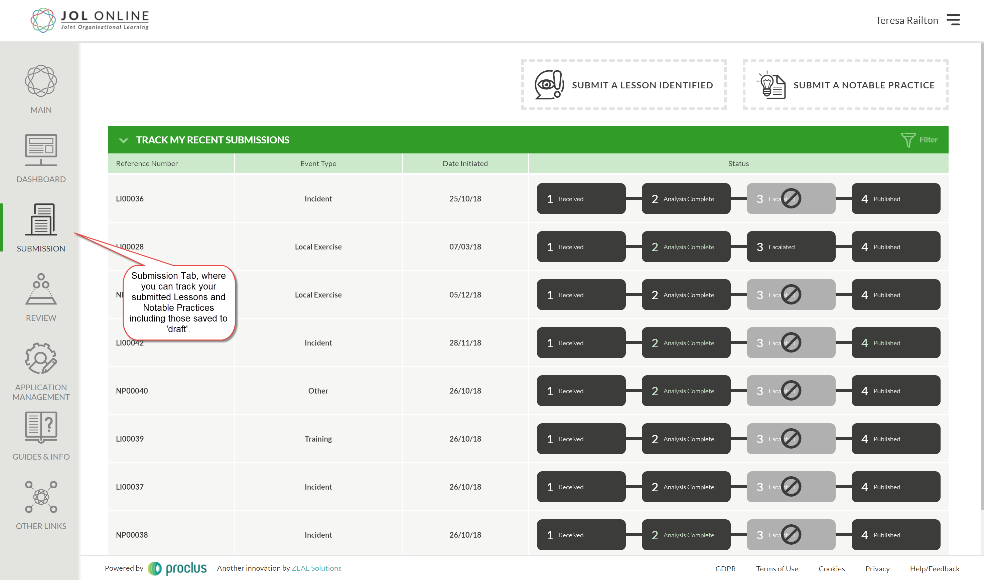

**Submission Tab**

1. Text added to the Registration and the Profile account setting area to clarify the JOL SPoC tick box when creating an account – to make users aware of the process for becoming a JOL SPoC

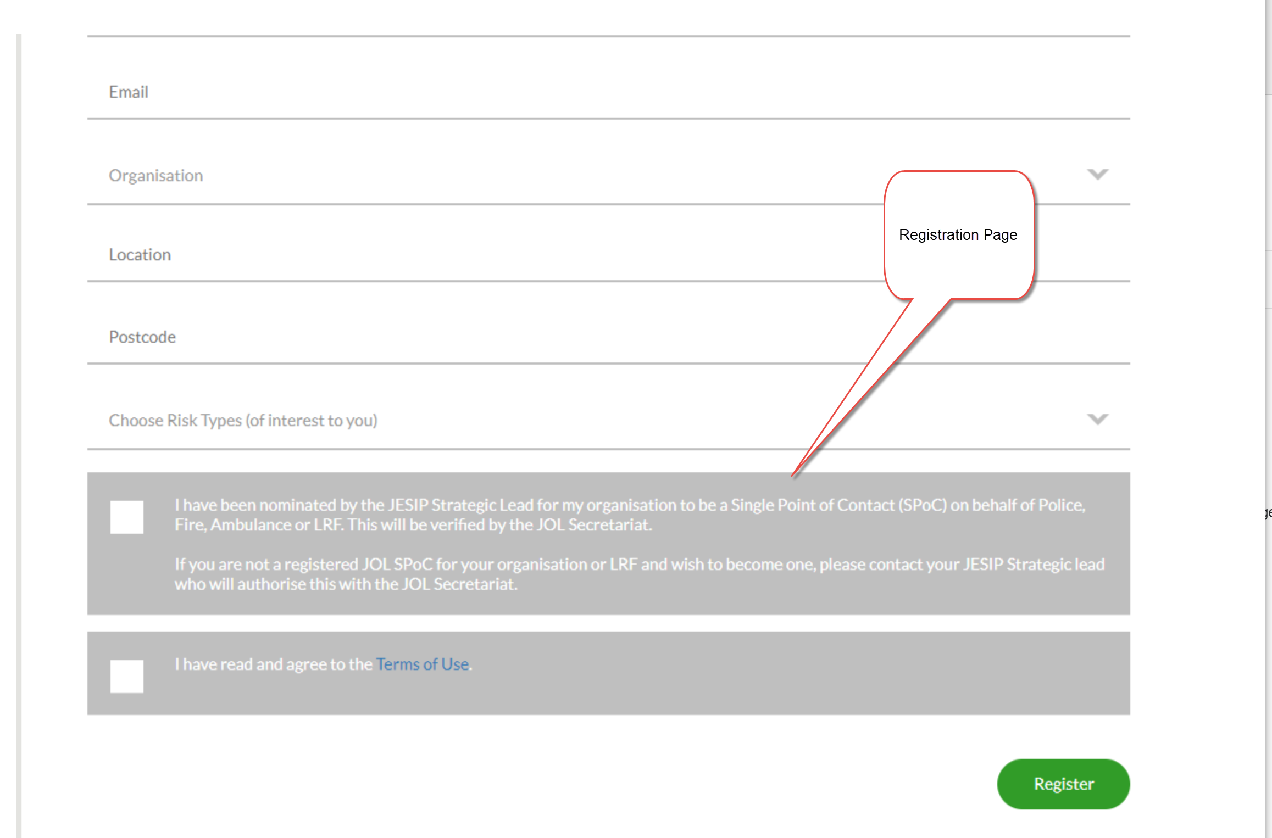

**Registration page**

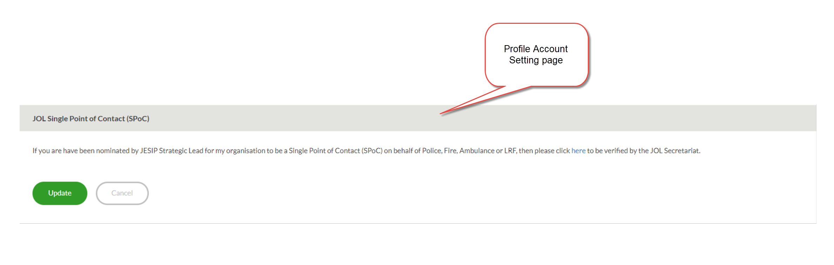

**Account/Profile Setting page**

1. Published submissions have been re-organised – so when viewing a submission you see the summary first

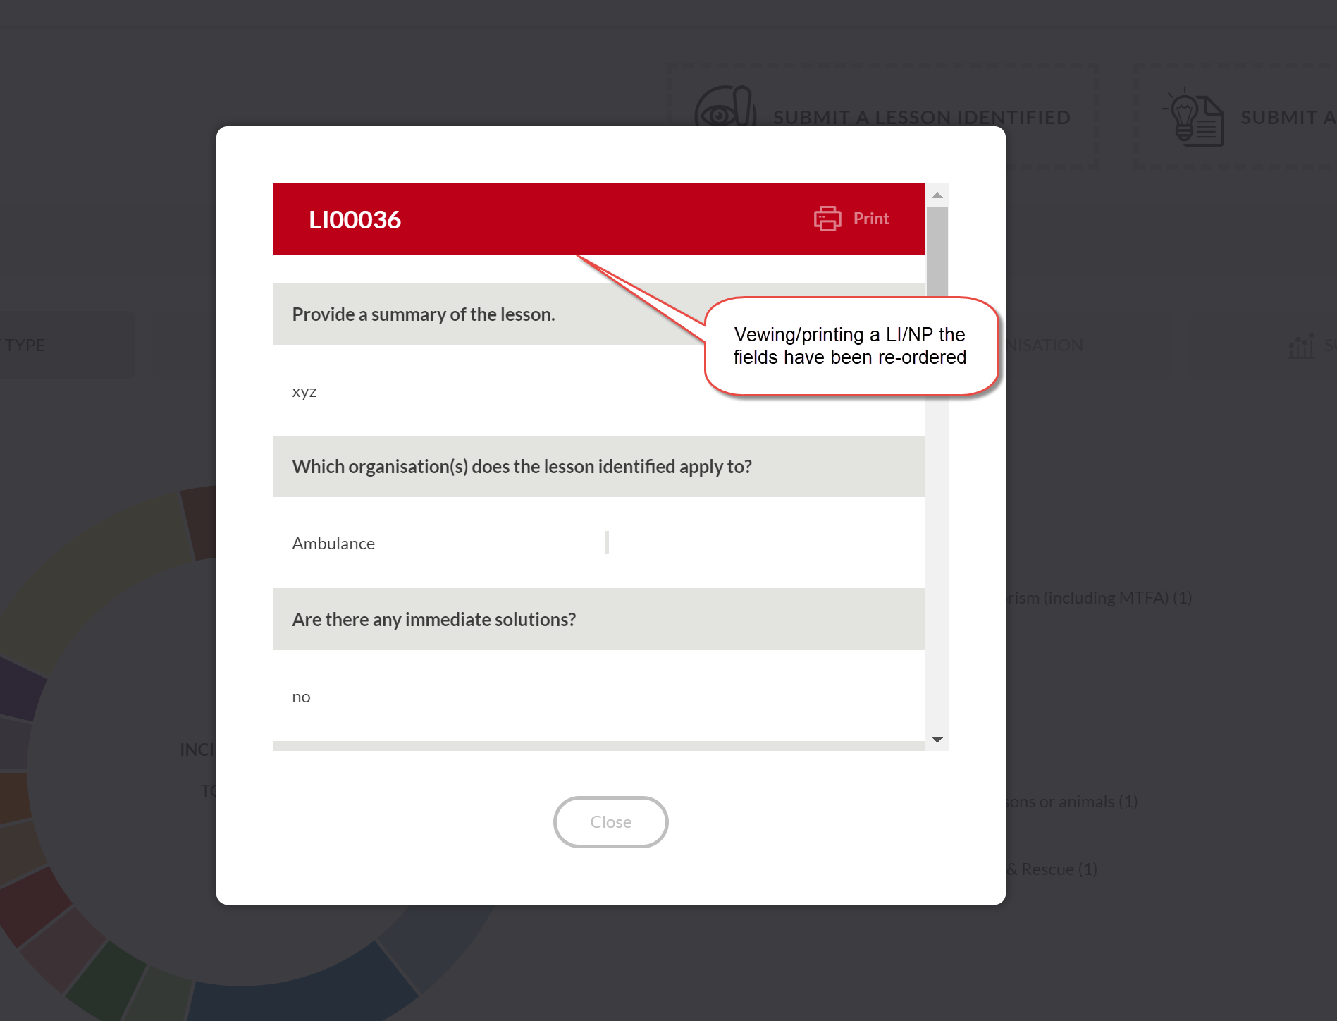

**Re-ordered fields when viewing LI/NP**

1. The location questions are now optional – to provide assurance of anonymity

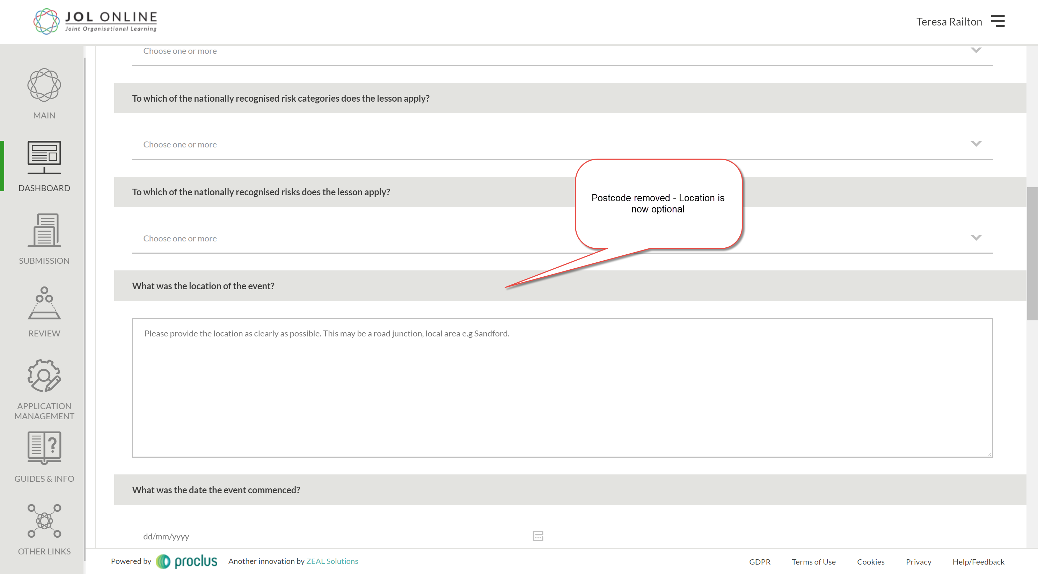

**Location field - Optional**

1. The footer bar has now been reduced to improve visibility on smaller screens

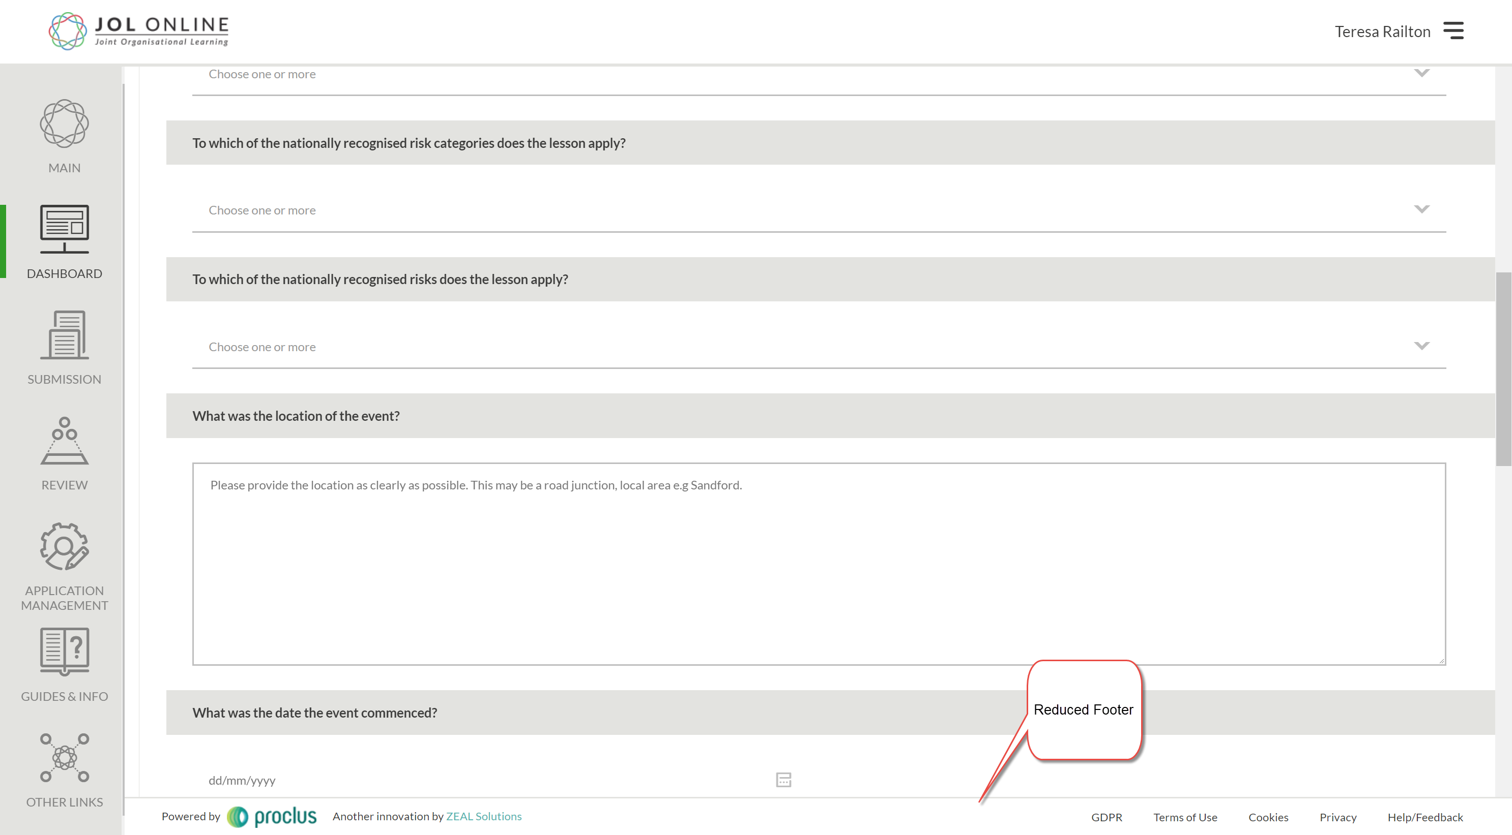

**Reduced footer**

1. You can now download reports regarding JOL Activity in graph format and print to PDF.

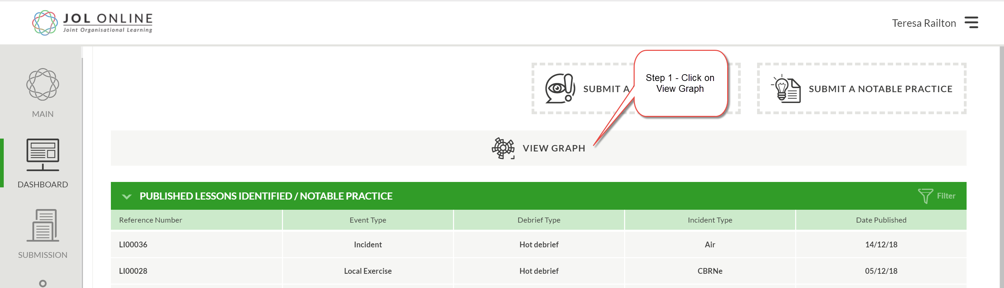

**Step 1 - Access Report**

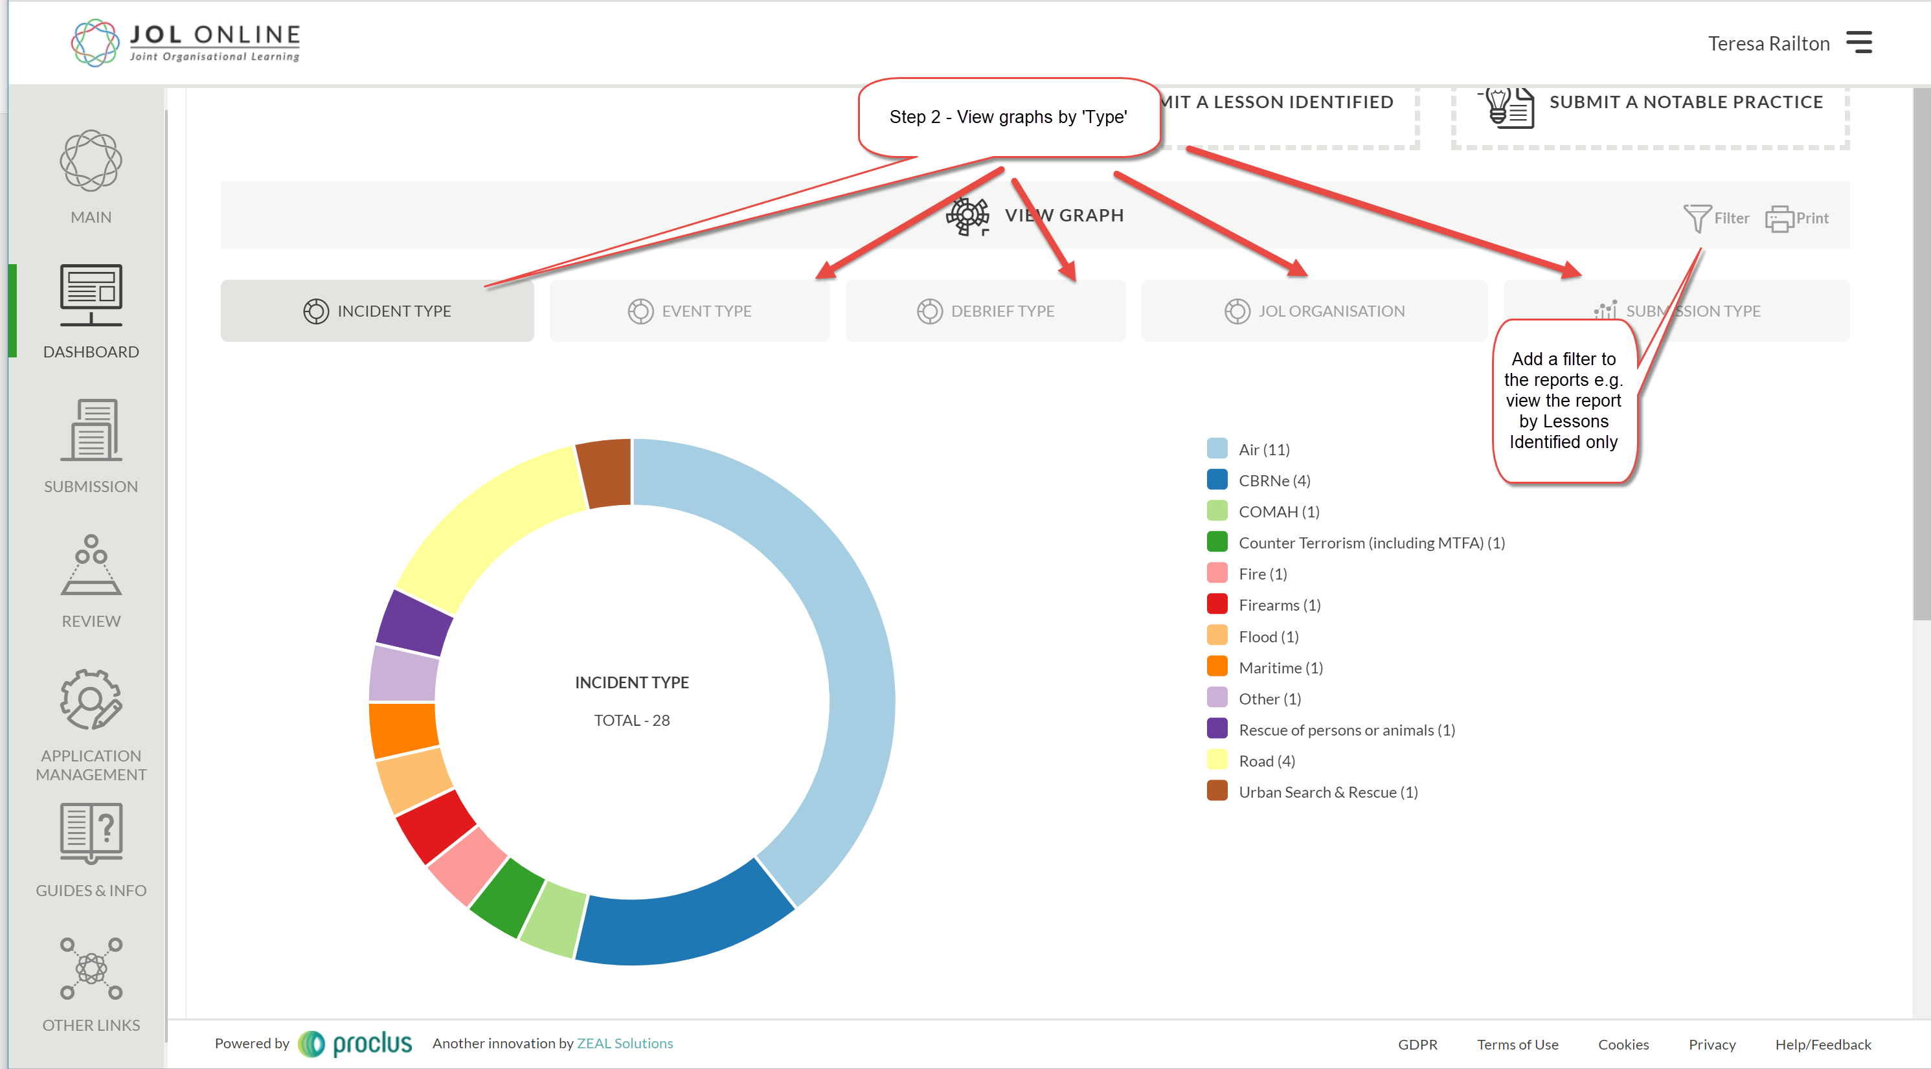

**Step 2 - Confirm Type of Graph/report – Add a filter**

