JESIP Multi-Agency Debrief Template
An aide memoire for debrief facilitators

Date of event:
Location:
Type of event (live incident, exercise, other)
Debrief team names:

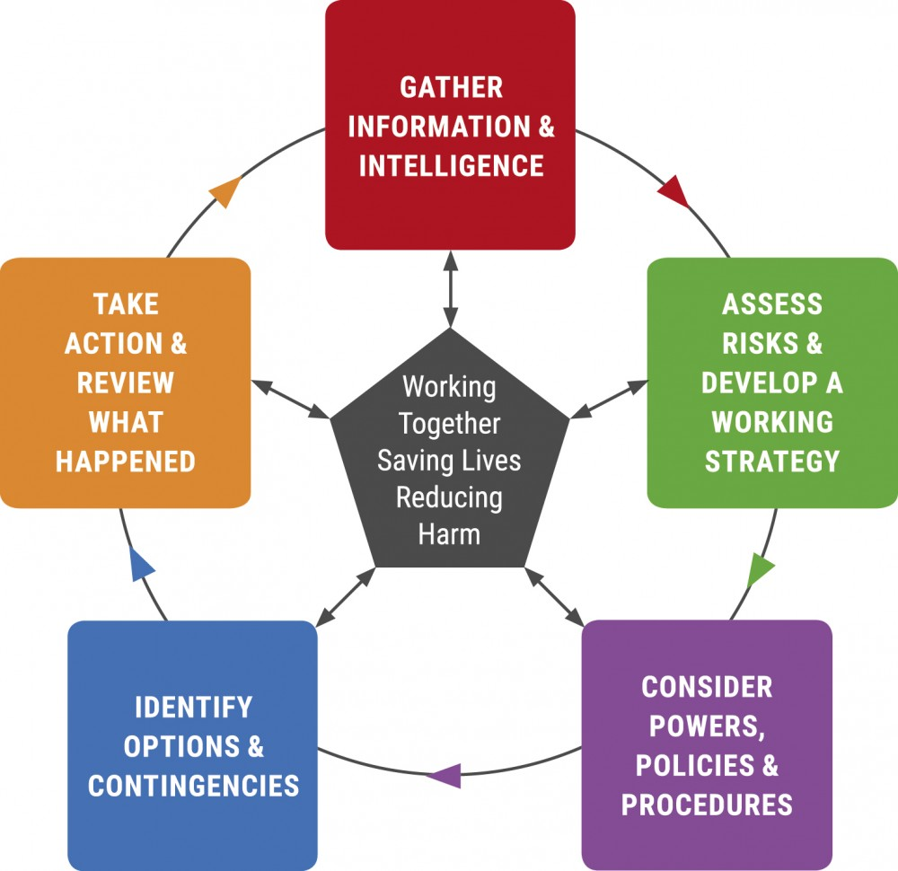

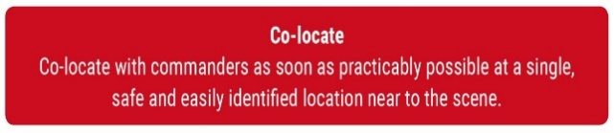

Were commanders easily identifiable?
What command structures were in place?
Did commanders meet face to face?
Was a Forward Command Post (FCP) established?
Did commanders have timely on-scene briefings?


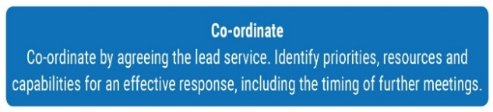

Was common terminology used?
Was an Airwave interoperability talk group used?
Was relevant information shared across all services and control rooms throughout the incident?
Was METHANE used to pass information to control?
Were effective communications established between:
Operational & tactical commanders/Commanders and control rooms/Emergency service commanders and other responding organisations/Local emergency service control rooms/Emergency service control rooms and national co-ordinating centres

Did Commanders use the JDM as single decision model?
Were Capabilities & Responsibilities identified?
Were joint decisions on priorities made and if so, how were the priorities arrived at and agreed?
Were actions joined up and therefore efficient and effective?
Were ALL on scene resources used appropriately?
Was there an understanding of the capability, capacity and limitations of each other’s assets?
Did someone take the lead co-ordinators role during Multi-Agency meetings?

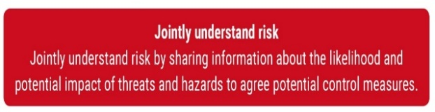

Were threats and hazards identified, understood and treated different by each emergency service?
Were limitations and capabilities of people and equipment identified?
Was a joint understanding of risk achieved by sharing information about the likelihood and potential impacts of threats and hazards?
e.g. sharing of risk assessments
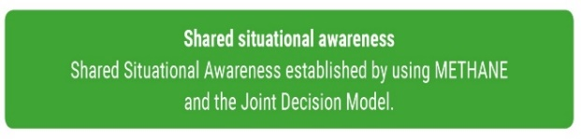
Submission to JOL Online

Did Commanders have a common understanding of what has happened, what is happening now and the consequences of events?
Did each of the emergency services understand their roles in resolving the emergency?
Was M/ETHANE regularly used to provide a Common Operating Picture (COP)

Was the Joint Decision Model utilised identifying:
Situation: What is happening? What are the impacts and risks? What might happen and what is being done about it?
Direction: What end state is desired? What is the aim and objective of the emergency response? What priorities will inform and guide direction?
Action: Were actions decided? What needed to be done to achieve a positive end state?
Do any of the issues raised during this de-brief meet the criteria for submitting to JOL Online? | Yes/ No (delete as appropriate)
Who will submit onto JOL Online? (agree with all parties)
Name | Organisation

Triggers for submission to JOL Online
The Lesson identified:
- May have an impact on responder agencies interoperability measured against JESIP Principles for joint working;
- May have a national impact;
- May impact on your organisations national standards;
- May impact on effectiveness of your sectors current national operational guidance, approved professional practice or doctrine;
- May impact on effectiveness of current national resilience capabilities;
- Is low impact but high frequency (trend) or;
- You want to share your lessons identified with other emergency responder agencies
to promote learning;
This is not a definitive list and if organisations feel that a lesson should be recorded on JOL, they should do so.

